BigStar French Bulldogs

Lesa & Jon Manoskey “TOADILY FRENCHIES”
610.587.3254
BigStarBulldogs@aol.com
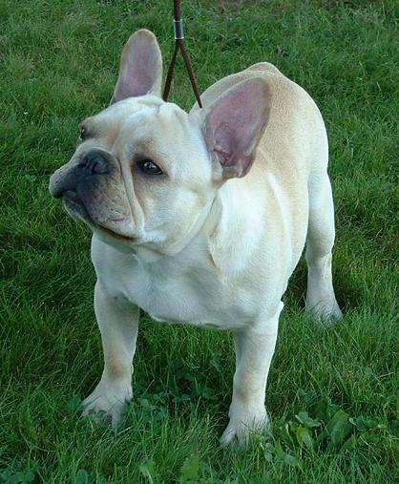
Please fill in completely:

HOW DID YOU LEARN ABOUT BIGSTAR? ______________________________________________________________________________

WHAT MADE YOU CHOOSE THIS BREED AS THE DOG FOR YOU? ______________________________________________________________________________

YOUR NAME ________________________________________________________________

SPOUSE/HOUSEMATE _______________________________________________________

E-MAIL ADDRESS____________________________________________________________

MAILING/STREET ADDRESS ________________________________________________

HOME PHONE _______________________________________________________________

PERSONAL REFERENCES: Please list three (3) with phone #
______________________________________________________________________________
______________________________________________________________________________
______________________________________________________________________________

How long have you lived at this address? ___________________________________________

Number of children in household & ages: ____________________________________________

Do you have tenants or relatives living with you? ____________________________________________

Have you ever owned a dog before: ____________

Do you live in a: House ( ) Apartment ( ) Farm ( ) Mobile Home Park ( )

Do you own? _______ If renting, do you have WRITTEN permission to have a housedog on the premises? _______ Please attach copy.

Do you have a yard that is: Yard fenced ( ) Kennel run ( ) No fence ( )

Fencing material used: Block wall ( ) Chain-link ( ) Welded wire ( ) Chicken wire ( )
Wood ( ) Other ( ) __________________

Please specify height of fence: ____________________________________

How many gates? ___________ Are they kept locked? _________

Will the dog be primarily: Inside ( ) Outside ( )

Where will the dog sleep at night? ________________________________________________

What shelter will be provided outside? Patio ( ) Shed ( ) Doghouse ( ) Garage ( )
Other ( ) please specify _________________________________________________________

Is there shade in the dog's area at all times during the day? ____________________________

Do you have a swimming pool? ____ If yes, is it fenced separately from the rest of the yard?_________

What is the primary reason you are considering a French Bulldog? Conformation( ) Breeding ( ) Companion ( ) Guard Dog ( ) Child pet ( ) Obedience ( )

Do you have a preference for sex, age, color, and personality?
____________________________________________________________________________________________________________________________________________________________

Are there any specific habits or problems that you are not willing to deal with?
______________________________________________________________________________

Do you believe a pet should be spayed/neutered? _____ If no, please explain ____________________________________________________________________________

Please list all animals you presently own:
Breed Time Owned Sex S/N ______________________________________________________________________________
______________________________________________________________________________
______________________________________________________________________________
______________________________________________________________________________
______________________________________________________________________________
______________________________________________________________________________

How many hours a day will the animal be left unattended? ____________________________

Does anyone in the family have allergies to animals? _________________________________

Who is your regular veterinarian? Name & phone # ___________________________ _______________________________
Are they familiar with this breed?______________________________

What is the activity level in your home?
( ) Busy - visits by friends, meetings, children, parties at home
( ) Noisy - T.V., stereo, machinery, tools, lots of kids playing
( ) Moderate - normal comings and goings
( ) Quiet - "homebodies", few guests

Under what circumstances would you NOT keep the pet? New Job ( ) Move ( )
New Baby ( ) Divorce ( ) Illness ( ) Other ( ) please explain: ___________________________
______________________________________________________________________________

An immediate health check is essential for the welfare of the dog and your peace of mind. This needs to be done within the first TWO-(2) working days of taking your dog home. Considering the high cost of veterinary are, are you willing and able to afford the necessary medical care and further vaccinations necessary to keep your dog healthy? ______________________________________________________________________________

Will you keep this pet up to date on vaccinations and licensing? ______________________________________________________________________________

Pet ownership is a serious responsibility. The whole family needs to be involved in the decision to get a dog. Our policy is to insure that each person who adopts a dog not only be aware of that responsibility, but that each person be willing and able to accept this responsibility morally, physically and financially. We have found that not every person who desires to own a French Bulldog should own one. They are unique and have some health concerns, but are wonderful in the right home.

This questionnaire was designed to aid both you and us in determining if you and your family are indeed adequately prepared to assume the type of responsible pet ownership we are endeavoring to provide for our dogs.

Please read carefully and sign:

I agree that if the information given on this questionnaire is not accurate to the best of my knowledge, I forfeit all rights and ownership of the French Bulldog acquired from BigStar.

I also agree that if at any time in the future I can no longer keep this dog, I will not give it away or sell it. I will contact BigStar for arrangements to be made for the dog's return to them.

I have read completely the above questionnaire, and understand it fully.

Applicant Signature _____________________________________

Date__________________

